**Project Specification Document**

NICTA

Ted Friedman

Eric Krenz

Sean Luthjohn

Jordan Steffan

**Table of Contents**

Section Page

Table of Contents

1. Project Vision and Objectives………………………...…………………………………..4

1.1 Project Scope and Vision 4

1.2 Project Goals and Objectives 4

2. Project Planning…………………………………………………………………………... 5

2.1 Project Lifecycle 5

2.2 Project Setup 5

2.3 Stakeholders 5

2.4 Project Resources 6

2.5 Assumptions 6

2.6 Estimates 6

3. Project Tracking………………………………………………………………………….. 7

3.1 Tracking 7

3.2 Communication Plan 7

Regularly Scheduled Meetings 7

Information To Be Shared Within Our Group 7

Information To Be Provided To Other Groups 8

Information Needed From Other Groups 8

3.3 Deliverables 8

3.4 Project Metrics 9

4. Requirements………………………………………………………….…………………. 10

4.1 Overall Description 10

4.2 Users and Roles 10

4.3 Use Case Diagrams 11

4.4 High-Level Requirements 11

4.5 Low-Level Requirements 12

4.6 Constraints and Limitations 13

5. Design……………………………………………………………………….................... 14

5.1 Introduction 14

5.2 Scope 14

5.3 High-Level Component Design 14

5.4 Activity Diagrams 15

5.5 Class Diagram 16

5.6 Sequence Diagram 17

5.7 Data Architecture 17

5.8 Alternative Designs and Design Rationale 17

6. User Interface……………………………………………………… …………………. 17

7. Test Plan…………………………………………………………………………………. 18

8. Project Closure…………………………………………………………………………... 18

8.1 Goals / Vision 18

8.2 Delivered Solution 18

8.3 Remaining Work 18

9. Deliverables……………………………………………………………………………... 19

9.1 Study Results 19

9.2 Requirements and Design Documents 19

9.3 Code 19

9.4 Tests and Test Results 19

9.5 Build Process Documents 19

9.6 Install Process Documents 19

9.7 Administrator’s and/or User’s Manual 19

9.8 Postmortem Document 19

9.9 Final Report 19

10. Definitions and Acronym…………………………………………………………….. 20

**1. Project Vision and Objectives**

**1.1 Project Scope and Vision**

Scope - We will format travel data, such as purpose of commute and type of transportation used, provided by NICTA to be displayed on the Australian National Map by utilizing QGIS, and utilities such as PostgreSQL to format and aggregate data.

Vision - Various users will be able to input additional travel data via a CSV file in the formats of the data supplied to us by NICTA and have it automatically usable and displayed by the Australian National Map.

**1.2 Project Goals and Objectives**

|  |  |
| --- | --- |
| **#** | **Goal or Objective** |
| 1 | Provide full documentation on our plans for, progress on, completion of, and how to use our system. |
| 2 | Build a system which can automatically format the first set of data for the national map. |
| 3 | Make this system easy to use and presentable as a prototype in time for midterm presentations. |
| 4 | Improve the system to make it automatically format the second set of data, and all future data, to be usable for the national map |
| 5 | Within time constraints, come up with new and creative ways for visualization of the formatted data on the national map. |
| 6 | Present final deliverables and documentation to NICTA and for our Capstone |

**2. Project Planning**

**2.1 Project Lifecycle**

For our project our team will use an agile approach. We have met with our sponsor to gather requirements and are creating a high level development plan that accounts for them. We have three large requirements which will be broken down and outlined in our project plan. We will then follow an approach based on frequent group meetings and communication while developing a system to meet the requirements.

**2.2 Project Setup**

|  |  |
| --- | --- |
| **#** | **Decision Description** |
| 1 | Travel data from Australian government in the form of a CSV |
| 2 | Standards that must be followed include the default Capstone coding standard. |
| 3 | Special access privileges needed, nondisclosure forms, must be taken care of. |
| 4 | Web server for testing environment |
| 5 | Fork of National Map for development |
| 6 | Github for project documents and data used. Accessible by group, professor, sponsor, mentor, and teaching assistant, |
| 7 | Group decision to use Google Drive for collaborative work on documents. Documents will be moved to Github, when completed. |

**2.3 Stakeholders**

|  |  |
| --- | --- |
| **Stakeholder** | **Role** |
| John Grundy | Sponsor |
| Iman Avazpour | Mentor |
| Dean Knudson | Instructor |
| Sean Luthjohn | Team member |
| Jordan Steffan | Team member |
| Eric Krenz | Team member |
| Ted Friedman | Team member |

**2.4 Project Resources**

|  |  |
| --- | --- |
| **Resource** | **Resource Description** |
| Team Github Repository | Will be used to store our project documents and data. |
| Capstone Team | Our team of students who will be the primary developers of the project. |
| Iman Avazpour | The mentor who will be able to provide us with technical assistance. |
| Google Drive | Collaborative work on project documents, which when completed will be moved to Github. |
| NICTA Repository | The code and information on the National map of Australia. We will use this to try and integrate the data into the map. |
| <http://visual.bts.nsw.gov.au/lga/> | Initial project data, provided to us by our project mentor. Data will be integrated into the National Map System. |
| Cesium | Javascript API that was used to make the National map. Will be helpful in learning how the map works and the code involved in making it. |
| John Grundy | The sponsor who will be able to provide us with some guidance and help with the project as we work. |

**2.5 Assumptions**

|  |  |
| --- | --- |
| **#** | **Assumption** |
| A1 | The sample data will be continuously delivered as we need it |
| A2 | The group will be able to continuously meet and make progress |
| A3 | The group will have continuous access to computers with Microsoft Project |
| A4 | We will be allowed access to all of the necessary data on the country |

**2.6 Estimates**

|  |  |  |
| --- | --- | --- |
| **Metric** | **Estimated Value** | **Actual Value** |
| Hours | 300 hours |  |
| Lines of Code | 1000 lines |  |
| Manual / Help Document Pages | 6 pages |  |
| Unit Tests | 75 tests |  |

**3. Project Tracking**

**3.1 Tracking**

|  |  |  |
| --- | --- | --- |
| **Information** | **Description** | **Link** |
| Code Storage | Project code will be stored on Github. | [Link](https://github.com/Fedoraman42/NICTA-NDSU-National-Map) |
| User Stories | HuBoard will be used for managing user stories and progress made on them. | [Link](https://huboard.com/Fedoraman42/NICTA-NDSU-National-Map/) |
| Continuous Integration | Will be added as necessary | N/A |
| Regression Testing | Will be added as necessary | N/A |
| Data Storage | Project data, and documents will be stored on Github | [Link](https://github.com/Fedoraman42/NICTA-NDSU-National-Map) |
| Sensitive Data Storage | Sensitive data will be stored on an encrypted Github by NICTA | N/A |
| Collaborative Work | Work on documents will be done on Google drive and then moved to Github upon completion. | [Link](https://drive.google.com/folderview?id=0B67oYcpJpbAnRUw5ajhsalRlUW8&usp=sharing) |

**3.2 Communication Plan**

**Regularly Scheduled Meetings**

|  |  |  |
| --- | --- | --- |
| **Meeting Type** | **Frequency/Schedule** | **Who Attends** |
| Conference Call | Weekly | Project team and mentor, possibly sponsor |
| Team Meeting | Twice a week & as needed | Project team |
| Short Meeting | Weekly before class | Project team |
| Sprint Planning Meeting | Start of each sprint | Project team and mentor |
| Sprint Retrospective Meeting | End of each sprint | Project team |
| Sprint Review Meeting | End of each sprint | Project team, mentor, and sponsor |

**Information To Be Shared Within Our Group**

|  |  |  |  |
| --- | --- | --- | --- |
| **Who?** | **What Information?** | **When?** | **How?** |
| Project team | Task assignments | At team meetings & as needed | Team meetings, listing in MS Project file. |
| Project team | Australian Data | When necessary as per development | Email, Github |
| Project team, mentor | Project Plan | At the beginning of each spring | Email, Skype, Github |

**Information To Be Provided To Other Groups**

|  |  |  |  |
| --- | --- | --- | --- |
| **Who?** | **What Information?** | **When?** | **How?** |
| Sponsor and mentor | Final report | At completion of project | Req./Design docs., code, Power Point presentation |
| Sponsor and mentor | Project baselines | At the end of each sprint | Onsite customer demo, access to repository |
| Sponsor and mentor | Weekly report | Weekly | Email and Trac site access |

**Information Needed From Other Groups**

|  |  |  |  |
| --- | --- | --- | --- |
| **Who?** | **What Information?** | **When?** | **How?** |
| Sponsor and mentor | Requirement changes | Start of each sprint | Conference call or meeting with sponsor and mentor. |
| Mentor | Australian Travel Data | As necessary | email, git or conference call |

**3.3 Deliverables**

|  |  |  |  |
| --- | --- | --- | --- |
| **#** | **Deliverable** | **Delivery Time** | |
| **Interim** | **Final** |
| 1 | Prototype Code | ▢ |  |
| 2 | Documentation on Prototype |  | ▢ |
| 3 | Prototype for Secondary Set of Data | ▢ |  |
| 4 | Documentation on Second Prototype |  | ▢ |
| 5 | Possible Adjustments to National Map for New Visualization Methods | ▢ |  |
| 6 | Final Documentation | ▢ |  |
| 7 | Finished Project | ▢ |  |

**3.4 Project Metrics**

|  |  |  |
| --- | --- | --- |
| **Metric** | **Frequency** | **Location** |
| Estimated User Stories | Per user story as set in the project plan with readjustment at the start of each sprint | MS Project Plan |
| Actual User Stories | Per user story to reflect actual work and time put into each user story | MS Project Plan |
| Estimated Sprint User Stories | At the start of each sprint based on past abilities | MS Project Plan |
| Actual Sprint User Stories | At the end of each sprint | MS Project Plan |

**4. Requirements**

**4.1 Overall Description**

Our project’s purpose is to help make mobility data easily accessible to the Australian public through National Map. To that end, we were given the task of making National Map capable of reading data from any format, a task that has broken into a simple two-step process. As of right now, National Map reads data that is formatted in a specific way; specifically, input data must contain latitude and longitude coordinates.

For the first step, we were given a sample dataset to work with. This sample data does not have latitude and longitude coordinates included. As such, we will have to find a way to make this data compatible with National Map during the first step of the project.

Once that is completed, we’ll move on to step two, where we’ll be given a second sample dataset to integrate into what we have working from step one. However, this new dataset will have some differences to it, making the problem of making it just as compatible with National Map as the first data set non-trivial. As a team, we have decided that as we can, we will keep this in mind and attempt to make the main task for step two as painless as possible as we work on step one.

**4.2 Users and Roles**

|  |  |
| --- | --- |
| **User** | **Description** |
| Public User | A regular user who can access data on the national map as well as input their own data onto the map provided it is formatted correctly. |
| Admin | A user who can make changes to how the National Map works along with utilizing the map like a Public User. |

**4.3 Use Case Diagrams**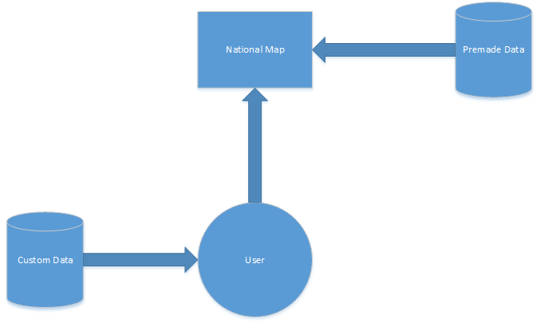

**4.4 High-Level Requirements**

5 Complexity Points Standard -- Fully analyze the ethics, stakeholders, and implications behind an ethical dilemma in the computer science world.

|  |  |  |  |  |
| --- | --- | --- | --- | --- |
| **ID** | **Added** | **Description** | **Status** | **Story Points** |
| 100 | Onset | As a user, I want to easily access mobility data for all LGA’s in New South Wales to gain knowledge about the best ways to plan my transportation. | **C** | **52** |
| 200 | Onset | As a user, I want to be able to view the mobility data in a web browser for easy access. | **C** | **13** |
| 300 | Onset | As a user, I want to specify what data to visualize and how to visualize it so I can access the data I want while having vast amounts of data available if I need. | **C** | **13** |
| 400 | Onset | As a user, I want access to the mobility data from more than just New South Wales if I live somewhere else in Australia. | **C** | **TBD** |
| 500 | Onset | As a user, I want to be able to compare and visualize data in different ways to aid in understanding it | **T** | **TBD** |
| 600 | Sprint 2 | As an admin, I want to be able to potentially add new data layouts in the future so users have more options for working with their data. | **T** | **TBD** |
| 700 | Sprint 2 | As a user, if I have moved or am moving into a new home I want to be able to see how people get from their homes to other locations such as work, the beach, etc… so I can travel efficiently. | **T** | **TBD** |
| 800 | Sprint 2 | As a user, I want to see mobility data for schools so I can plan my child’s route to school more effectively. | **T** | **TBD** |
| 900 | Sprint 2 | As a user, I want to be able to calculate time differences so I can choose varying routes that still fit my schedule. | **T** | **TBD** |
| 1000 | Sprint 2 | As a user interested in urban planning I want to combine multiple data sets to be viewed simultaneously to aid in the planning process. | **T** | **TBD** |
| 1100 | Sprint 2 | As a user interested in urban planning I want to view if transportation options typically avoid schools so as to plan routes efficiently. | **T** | **TBD** |
| 1200 | Sprint 2 | As a user interested in urban planning I want to see if more trains on a line affect choices made by the public to know if more trains are worth the investment. | **T** | **TBD** |
| 1300 | Sprint 2 | As a user interested in political science and demographics, I want to be able to view mobility data based on political affiliation in order to show voter demographics. | **T** | **TBD** |
| 1400 | Sprint 2 | As a parent searching for ways to transport my children to school, I want to view and contrast different methods of transportation in the area so I know what the most effective and common form of transportation is for my situation. | **T** | **TBD** |

**4.5 Low-Level Requirements**

|  |  |  |
| --- | --- | --- |
| **ID** | **Description** | **Verification** |
| 110 | Obtain data for LGA’s in New South Wales | We received it and have it stored with our data. |
| 120 | Format data for LGA's in New South Wales | Comparison against data currently working on the National Map |
| 121 | Learn how the data is parsed by the National Map | Test using data which we know works |
| 122 | Determine the best way to format the data for National Map | Look at existing formatted datasets |
| 130 | Input data for LGA’s in New South Wales into National Map | User the interface provided and make sure it displays correctly by starting with small sets of data |
| 210 | Data needs to be formatted correctly for mobility data | Analyze existing formatted data |
| 220 | Data needs to be fed into the map program for mobility data | Use the interface provided or develop our own |
| 310 | Checkboxes will allow data selection | Our new data is accessible with checkboxes |
| 320 | Data needs to be separated based on selection | Make sure checking boxes adds data, unchecking boxes removes data, and boxes work in conjunction with each other |
| 410 | Obtain new data for LGA’s in a second Australian state | Set up private repository and get new data from source |
| 420 | Format new data for LGA’s in second Australian state | Set up private repository and get new data from source |
| 430 | Import new data into National Map | Use the interface provided and make sure it displays correctly by starting with small sets of data |

**4.6 Constraints and Limitations**

|  |  |
| --- | --- |
| **Constraint** | **ID** |
| Getting access to currently working National Map data. Currently do not have access to data. | 100,  200 |
| Inability to have all datasets in our public repository, because of security issues. | 400 |

**5. Design**

**5.1 Introduction**

This project consists of a set of modules for formatting data for National Map - one to receive the input data and determine what to do with it, and one for translating the data from each possible input format into the required format for National Map. The general public along with administrators can utilize it to put data into National Map. If our sponsor requires more data formats to be accepted in the future, it should be trivial to add an additional translation module.

**5.2 Scope**

We are building a set of queries for National Map to ensure that data uploaded to the map will be formatted correctly for the map to display. This will take place between the user interface and the application of the data onto the map in a way which appears seamless to the user.

**5.3 High-Level Component Design**

This diagram shows the components we will be developing for this project. Additional formatting modules can be created as needed based on the different formats supported.

|  |  |
| --- | --- |
| **Component** | **Description** |
| Data Interpreter Module | Makes sure data to be displayed in National Map is in the appropriate format. Must be able to read input data from multiple formats. |
| Data Formatting Module | Receives data from the input module. Each output module should only have to deal with translating one possible input data format into the National Map format. |
| Data Output Module | Receives data from translation modules. Data received from all modules will be in the correct format. This module will act as a universal hub for all data to be displayed, so the call to display data only needs to be written once. |

|  |  |
| --- | --- |
| **Component** | **Related Requirements** |
| All Modules | Sample datasets that utilize formats different from what National Map expects |

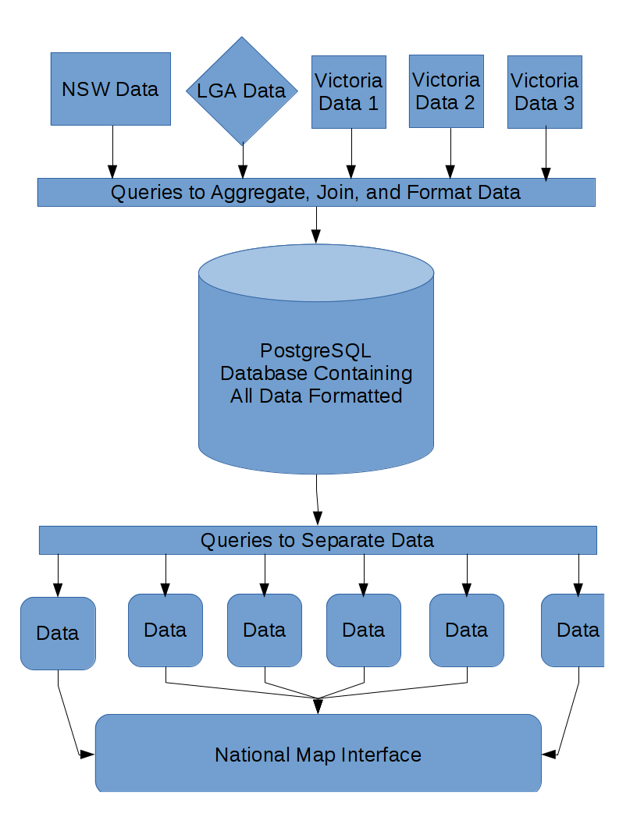

**5.4 Activity Diagrams**

We don’t know precisely how our formatting modules will work as of yet, but we will update this document accordingly as we make progress on them.

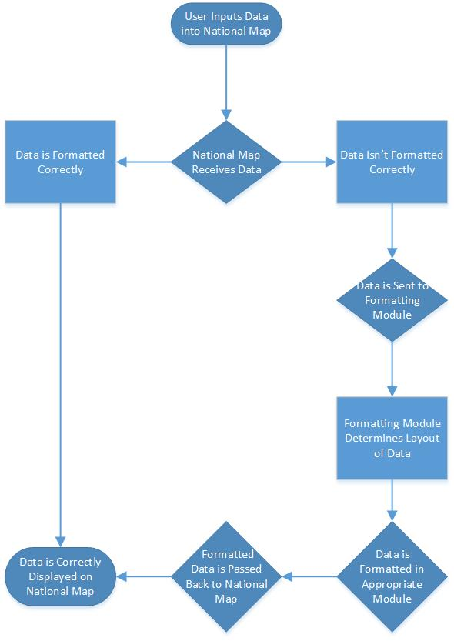

**5.5 Class Diagram**

*This project does not require us to create classes. All existing code we received from our sponsor is written in JavaScript, which does not have any defined “class” structure.

**5.6 Sequence Diagram**

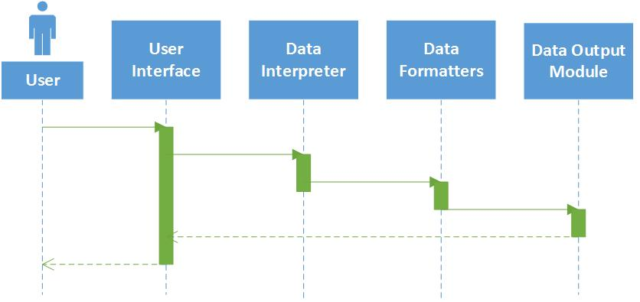

**5.7 Data Architecture**

We have been told by our sponsors that there is a specific format we need to work with, but we are currently not sure what that format is. We have been told to use QGIS (Quantum Geographic Information System, an open-source software tool) for all data translation, as the engineers working on National Map already use it extensively.

We will also be getting in touch with one of the engineers who developed National Map as soon as possible for additional information to determine the required format so we can begin developing our component for National Map.

**5.8 Alternative Designs and Design Rationale**

One alternative we came up with was to have one translation module to do everything. We ultimately decided to go with a multi-module approach instead of a single module to simplify the code we’ll have to write; it will be much easier to debug one of several modules that are each only fifty lines of code than to debug one big module that has all that code and possibly additional logic.

Another design idea was to have a separate console application for formatting data. This design was less ideal because since the general public can upload and apply their own data to the map, each person would have to use the console application beforehand. Integrating the formatting tool directly into the map upon upload allows for a seamless interaction for the general user.

**6. User Interface**

Our project is more of an addition into the current map interface rather than utilizing its own UI, so this section isn’t applicable to our project.

**7. Test Plan**

This section has been deemed unnecessary for our class this semester

**8. Project Closure**

**8.1 Goals / Vision**

In the end, our project turned out a little different that first envisioned, however, from a user story perspective, the end goal remained largely the same. The way we chose to implement and finish our data aggregations are different than our initial plans for the data, however the end goal remains largely the same, with the exclusion of the completion of any stretch goals. In the end, we are proud of what we have delivered and believe it will come of some use to our company.

**8.2 Delivered Solution**

As for our deliverable, it is made up of a collection of SQL Scripts and Queries. The collection of these items are designed to build a database from the specific format of data that we were given it in, and aggregate it into a single database. From this database, the have built-in functions to pull data files from the database that can be fed into the map for displaying.

**8.3 Remaining Work**

Ideally the aggregation process would be comprehensive for data from the remaining regions of Australia so that the National Map would be able to show data from all of them rather than just New South Wales and Victoria. Along with this, we didn’t reach our stretch goal of finding new ways to visualize the data on the map, so that would be a natural progression of improvement to make on this project.

**9. Deliverables**

**9.1 Study Results**

We did not perform any studies as a part of this project.

**9.2 Requirements and Design Documents**

The requirements and design documents are included in the repository provided as the deliverable

**9.3 Code**

All relevant scripts and code are included in the repository provided as the deliverables.

**9.4 Tests and Test Results**

This is not relevant to our project.

**9.5 Build Process Documents**

Any necessary build process documents will be included with the scripts in our repository.

**9.6 Install Process Documents**

Any necessary installation process documents will be provided in the repository.

**9.7 Administrator’s and/or User’s Manual**

This is not relevant to our project. Instructions on using our scripts will be in the build process document.

**9.8 Postmortem Document**

The final postmortem document will be included in the repository.

**9.9 Final Report**

The final report document will be included in the repository.

**10. Definitions and Acronyms**

|  |  |
| --- | --- |
| **Term** | **Definition** |
| NICTA | National Information Communications Technology Australia |
| LGA | Local Government Area |
| CSV | Comma Separated Values |
| QGIS | Quantum Geographic Information System |
| PostGIS | Post Geographic Information System |
| PostgreSQL | Postgres Structured Query Language |